First, Below is the case mgt for the registration form.... hidden value "counter" gets saved as case property "counter" ....

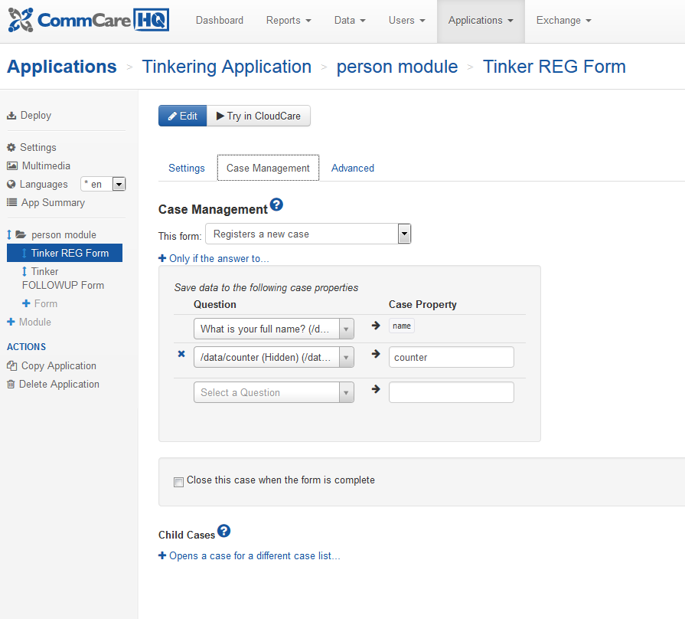

And below you will see the actual form of the reg form. Here you see that hidden value counter is simply 1. Ignore all that other stuff in the form, that was stuff from other things I was testing.
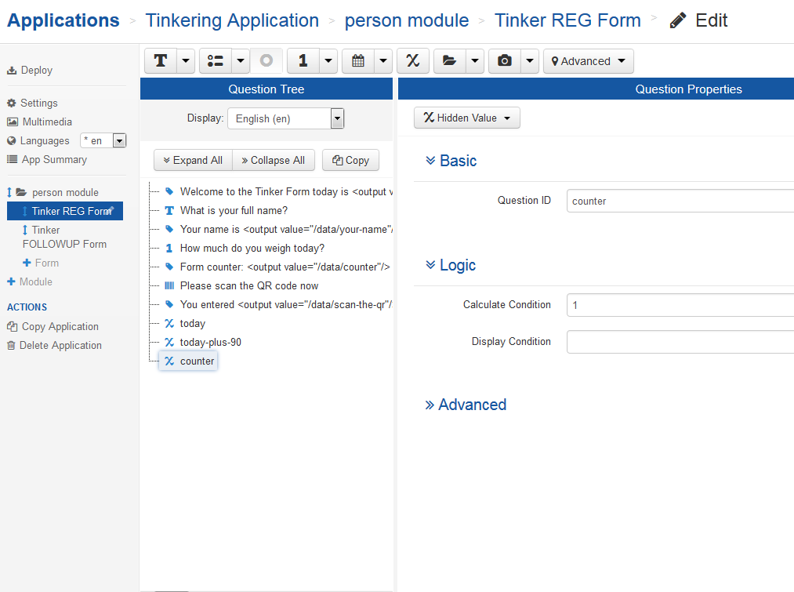

And below you see the case mgt for the FOLLOW-UP form, ... it loads the case property counter into a hidden value called loadcounter... and then afterwards, it will store plain old counter into the case property "counter."
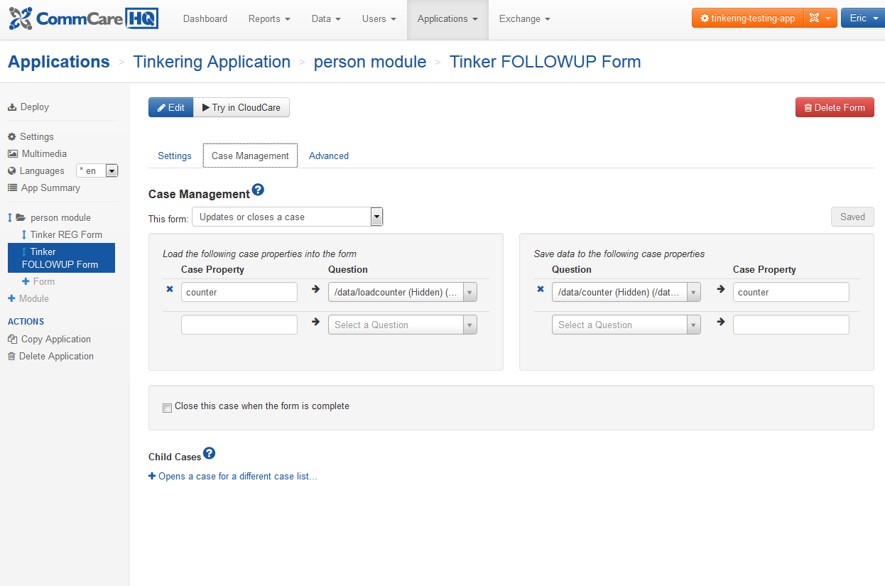

And below is the actual FORM for the follow-up form. I have selected the hidden value counter so you can see its simple formula. Of course, for loadcounter, there is no formula or calculation of any kind. It just gets loaded to.

