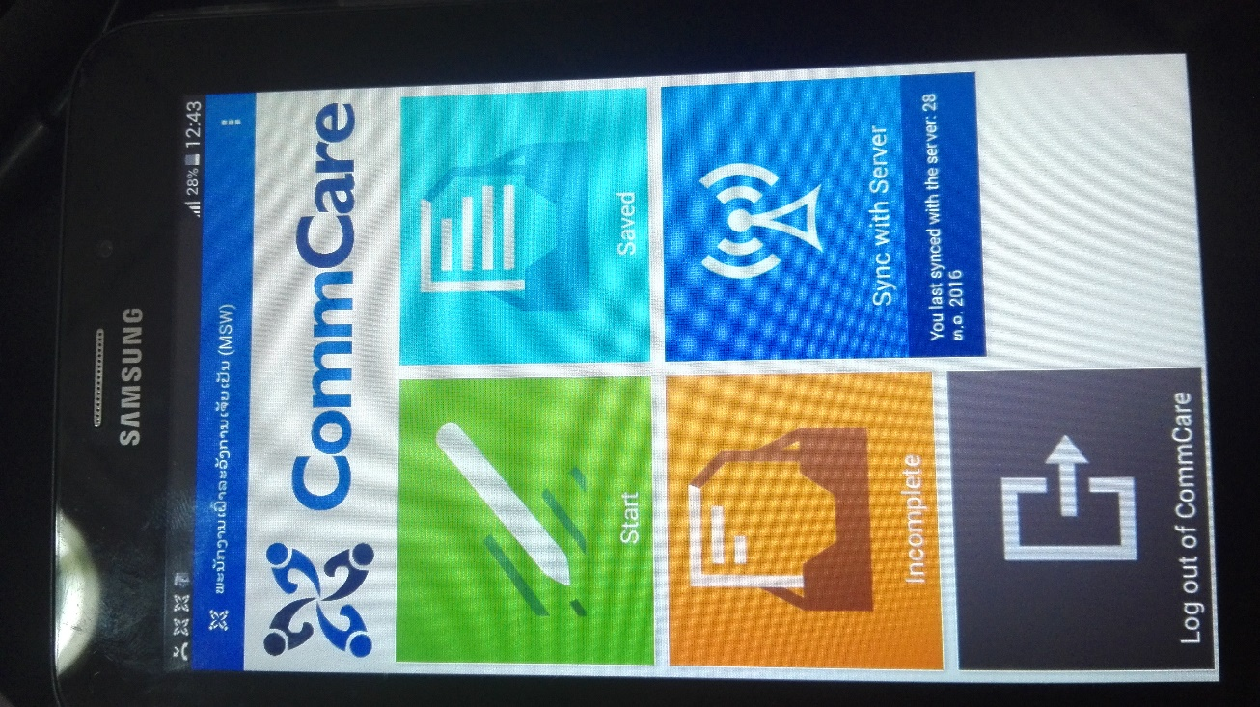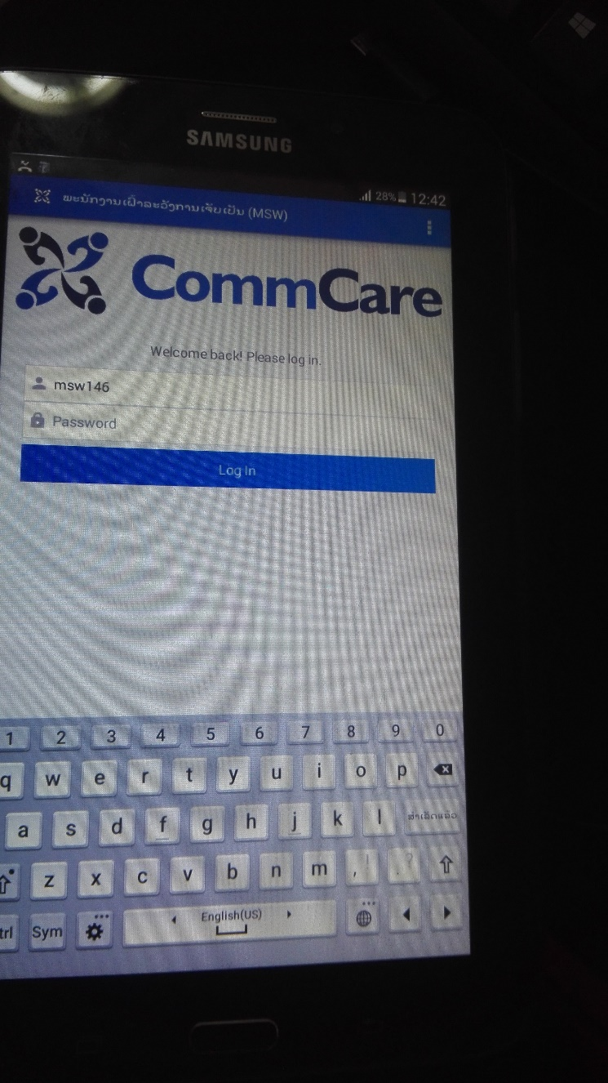

The previous project that we used commcare has 3 dot in the right hand corner, I’ve compare the setting of the new one and the old project, it is the same now for the setting , . I’ve used Sumsung tab 3 .

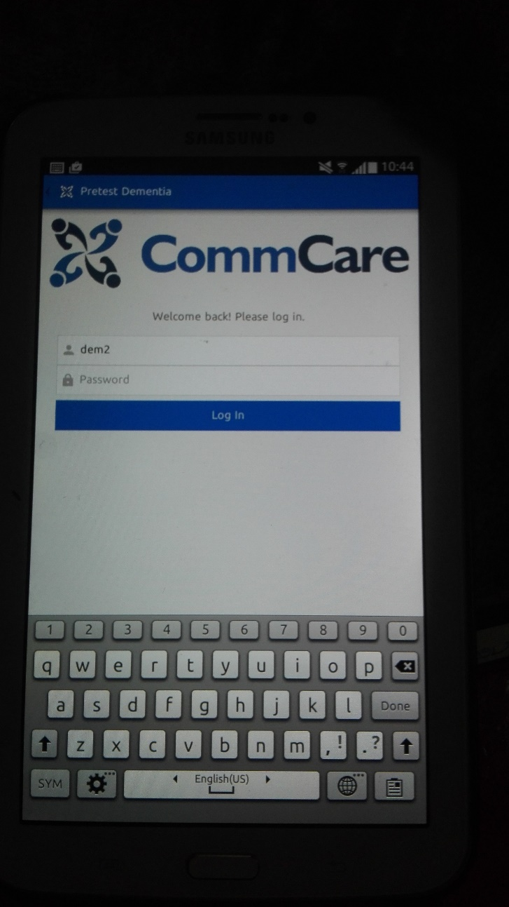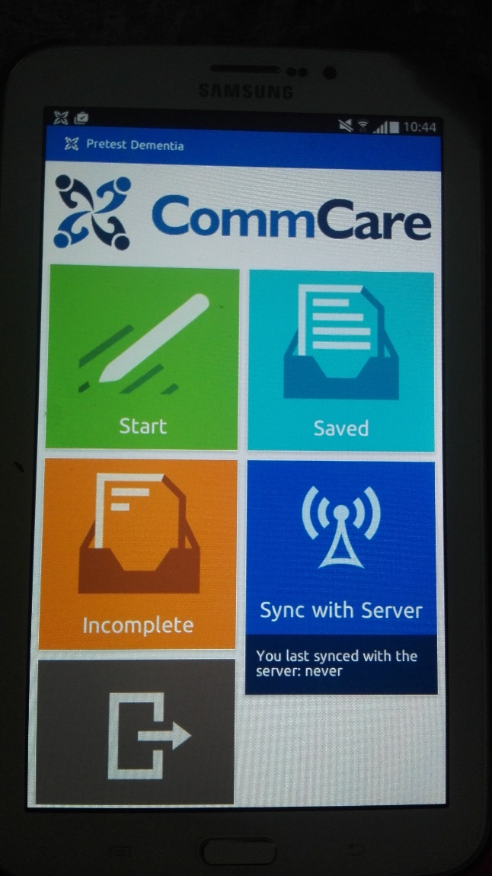

New commcare update, after change the setting the saved and incomplete appear but still don’t have 3 dot in the right-hand corner I ‘ve used Samsung tab 2 for this app